How to Create a Non-Catalogue Requisition
1.1. SCM_RSSP_How to Create a Non-Catalogue Requisition

Create a Non-Catalogue Requisition in Redwood
Non-Catalogue Requisition is where the requisition is for goods and services that cannot be met via existing catalogues.
Note: You must have sourced your requirement from a reputable supplier before starting this process.

Log on to UniCore using Single sign on

Find ‘Procurement’ in the horizontal menu, and click on the ‘Purchase Requisitions (New)’ tile
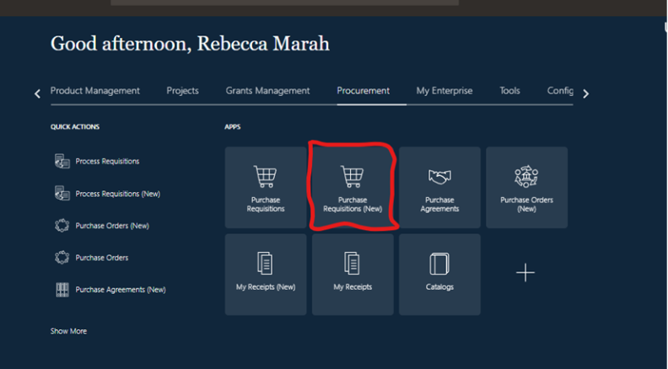
At the bottom of the screen, click on the ‘Create Noncatalog Request’ button.
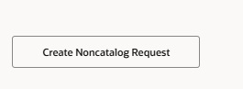

- Enter in a brief description of the requirement in the ‘Item Description’ field
- Click on the dropdown arrow in the Category Name field. Note: Please ensure you select the correct Category Name type. Proc-HE codes are a national coding convention used by procurement professionals in the higher education sector to categorize goods and services. They help standardize the categorization of spending on goods and services across universities and colleges in the UK. The Higher Education Procurement Association (HEPA) is responsible for managing and updating the list of codes.
- Start typing and select your item from the predicted list. If not shown in results, do a blank search to see all items
- If the requisition is billed by quantity, enter the quantity of goods required. Then click in the ‘UOM Name’ field and select from the dropdown box. Note: UOM means Units of Measure. You will see numerous options to choose from here. i.e. Each, box or bag etc.
- Enter the price and currency into the correct fields

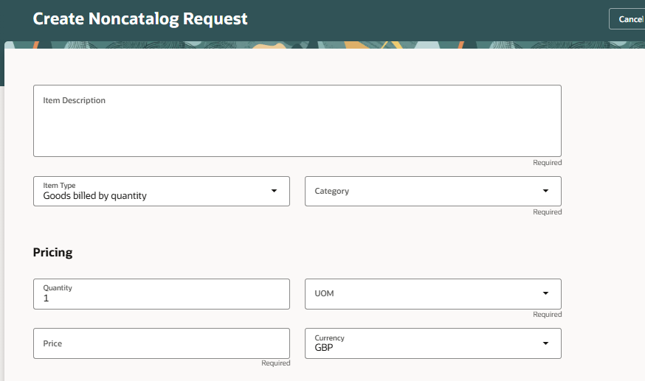

Within the Source section, in the Supplier field, you can use the dropdown to view the list of suppliers or start typing to view the search results and select the supplier from the list.

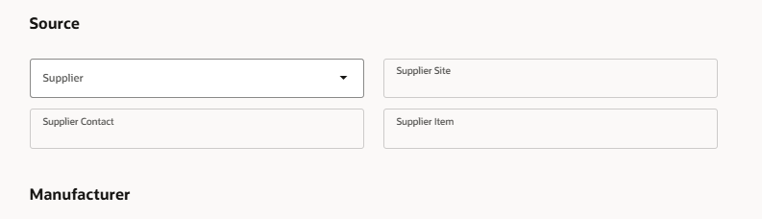

At the bottom of the page, you have additional fields to add notes, attachments and links if required:
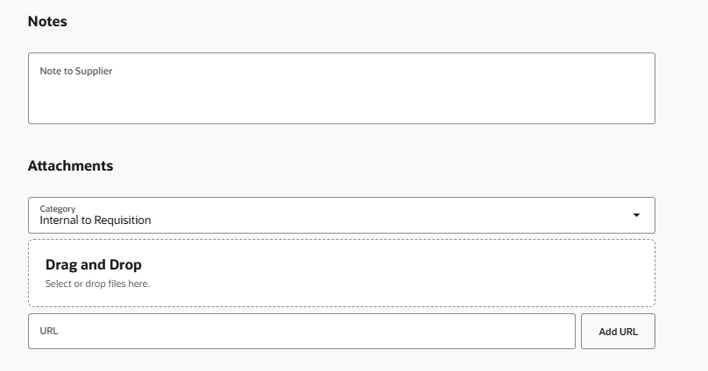

You can use the Category field to determine whom you want the document to be sent to;
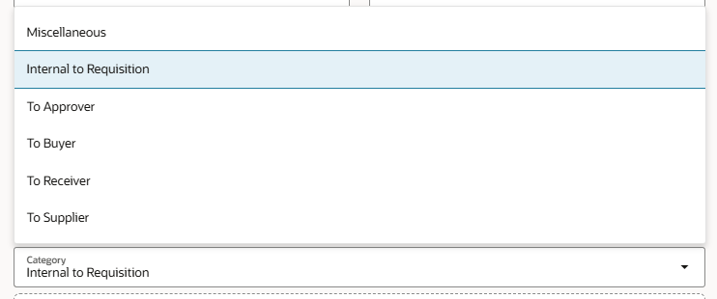
- To Approver: If you select ‘To Approver’ option, then attachment will be visible to only approver of the document.
- To Buyer: If you select ‘To Buyer’ option, then attachment will be visible to only Buyer of the document.
- To Supplier: If you select ‘To Supplier’ option, then attachment will be visible only to the Supplier of the document.
- Miscellaneous: The 'Miscellaneous' category is used when the other attachment categories don't fit. There is no specific intent. It will be communicated to the supplier and buyer if the category is used.
Note: The user should not use Miscellaneous, unless he knows the other categories will not fit, or if the user needs to send one attachment to multiple groups such as suppliers and buyers.
- To Receiver: If you select ‘To Receiver’ option, then attachment will be visible to the Requester on Purchase order hyperlink while creating the receipts.

Once all the details are entered, Click ‘Add to Cart’. Line will be added to Cart.
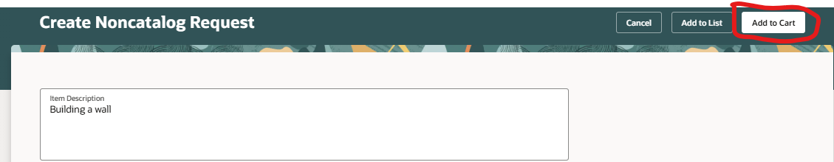

If you need other items to be included in the order and for the same supplier, you can click ‘Create another request’ in the pop-up that appears and repeat steps from selecting the product/services until adding it to cart. Once you’re happy, click ‘View Cart’ to proceed.

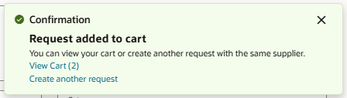

You will be redirected to your Cart, where you can view high level details of your requisition and also start adding additional information.
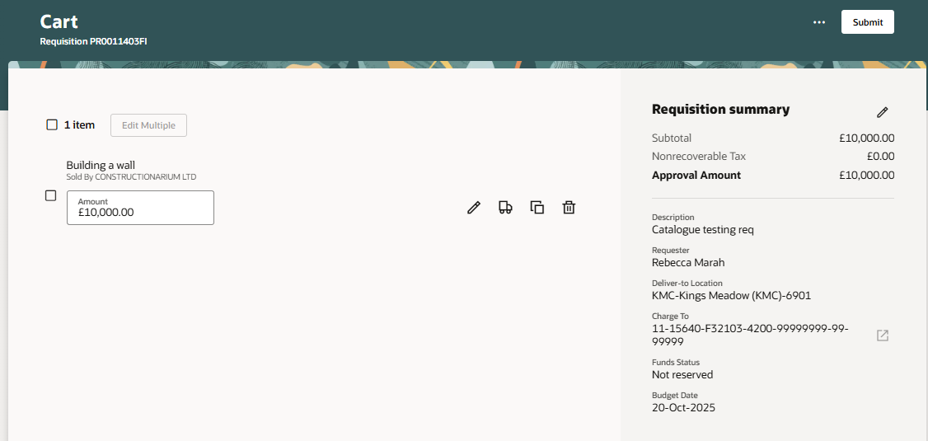

Depending on how many lines you have in your requisition Depending on the business requirement, provide mandatory Health and safety/Technical approval, Delivery Room Number, Justification (will be seen by approvers), in order to proceed.
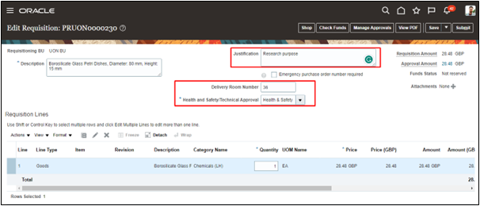

The Requisitioner can also update Delivery details for each of the requisition lines. The information below can be updated in the delivery section.
- Requester: this is the person on whose behalf the requisition is required to be created. Requester name is defaulted from the Requisition Preference.
- Requested Delivery Date: this is the date by when the requisitioner wants supplier to deliver the goods. By default, it will be 7 days from the present date. Requisitioner can change the date as required.
- Deliver to Location: this is defaulted from the Requisition Preference. Requisitioner can update ‘Deliver to location’ if required by clicking on the magnifying glass and searching the relevant location. ‘Deliver to Address’ details shall be defaulted based on Location name. Requester can also use one time location and enter location details.

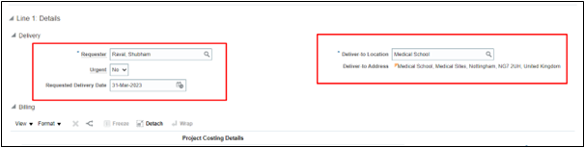

Note: It is important to note that delivery details are unique for each requisition line. Requisitioner must click on the requisition line for which delivery details are required to be updated.

Specify Charge Account Details in the ‘Billing’ Section.
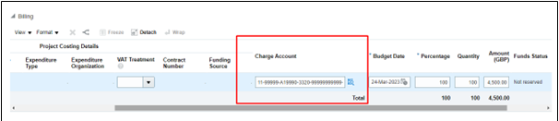

If the requisition is for a specific project, enter the relevant project details such as, Project Number, Expenditure Type, etc.
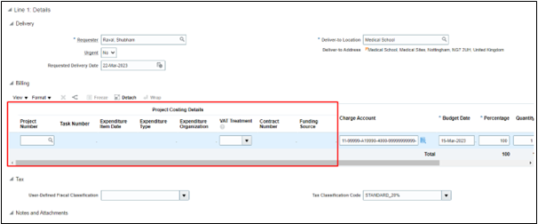

- Project Number: enter the project number incurring the charge from the requisition, purchase order, or invoice.
- Task Number: the lowest level task incurring the charge from the requisition, purchase order, or invoice.
- Expenditure Type: is an expenditure type classified with an expenditure type class of Supplier Invoices.
- Expenditure Organization: the organization that is ordering or has ordered the goods or services, which may be different from the project owning organization.
- Expenditure Item Date: the date that you expect to incur the expense for the goods or services that you are requesting for a requisition or purchase order, or the date that you incur the charge for an invoice. This date is used during online validation against project transaction controls and becomes the expenditure item date on the expenditure item in Oracle Projects.

Note:
- Contract Number and Funding source will be enabled and mandatory if the project number entered in project number segment is of capital type
- VAT treatment dropdown should have the same value as User-Defined Classification drop down or your requisition will get auto rejected.
- When making any purchases on a project, the Expenditure Type and the Account in the Charge Account must match. Inconsistencies are causing us challenges in keeping the project ledger and the general ledger reconciled.
- We are aware that it is possible to change the Expenditure Type manually. The account in the Charge Account string is derived from the product code of the purchase item and is fixed. It is therefore necessary to change the Expenditure Type to match the Account in the Charge Account string before submitting the purchase order.

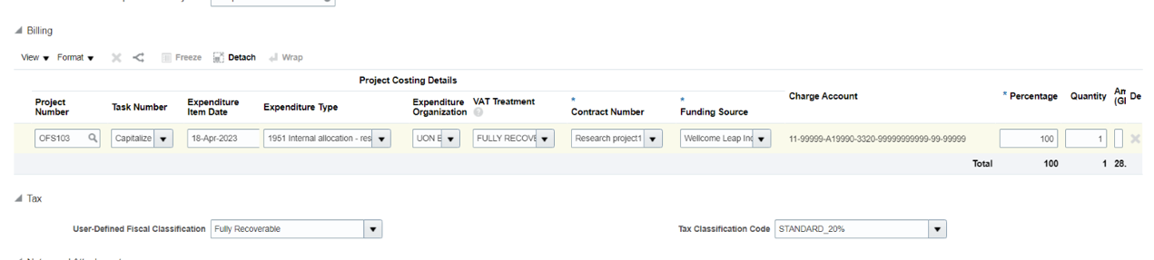

Users can update Cost Centre and other codes in charge account as per the business need. Please refer to the table below for the configuration.
Sr. No. | Segment | Default based on | Can requisitioner update manually?
1 | Company | Requisition BU | No
2 | Cost Center | 1. Employee preference account  2. Employee default expense account | Yes
3 | Purpose | 1. Employee preference account  2. Employee default expense account | Yes
4 | Account | Proc. HE category | No
5 | Analysis | 1. Employee preference account  2. Employee default expense account | Yes
6 | Intercompany | 1. Employee preference account  2. Employee default expense account | No
7 | Spare | 1. Employee preference account  2. Employee default expense account | No

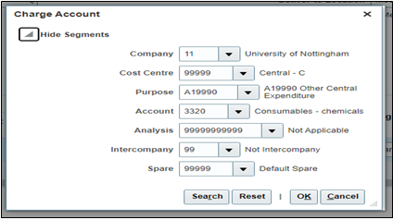

Note:
- **As part of best practices, it is advised not to have multiple requisition lines having multiple cost centres. **
- Apart from Cost Centre segment, you can also update the other segments of the Chart of Account. System will fetch the values based on pre-configured rules and will get the mapped code against the segment. For Ex: Account value code will be defaulted based on selection of category.
- Billing Information is specific to the requisition lines. You need to click on the particular requisition line to update.

- Users need to check and specify User defined fiscal classification and correct Tax Classification Code under Tax for each line.

Once all details have been completed, Click ‘Save’
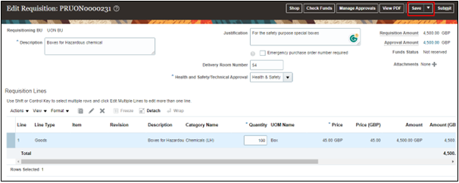

If the requisition is for a specific project, enter the relevant project details

Click on ‘Manage Approvals’ to see the approvers to whom the Requisition approval notification will be sent.
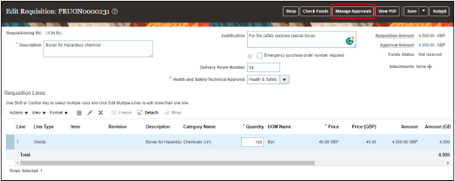

The requisition will auto approve on the requisition level and will be checked and approved on the buyer’s dashboard level.

The table below shows the stages of approval flow.
Approval Stage | Approvers/Reviewers | Condition
FYI Stage | Procurement Team | New Supplier Check Box is Yes
Buyer's Dashboard
Stage-1 | Project Manager | Project Type Requisition
Stage-2 | Cost Centre Based Approval Groups | Mandatory Stage Applies to all Requisitions
Stage-3 | Technical Team | When Requester Chooses Technical or Technical+H&S on Requisition Header DFF
Stage-4 | Health & Safety Team | When Requester Chooses Health and Safety or Technical+H&S on Requisition Header DFF
Stage-5 | Tax Team | When Requisition Amount is Greater Than 5K and Tax Classification Code is Medical 0%
Stage-6 | Procurement Team | When Requisition Amount is Greater Than 25K
Stage-7 | Procurement Director’s Team | When Requisition Amount is Greater Than 200K

Once all details have been reviewed, and any relevant documentation attached using the ‘Notes and Attachments’ section, click ‘Submit’ to submit the requisition for approval.
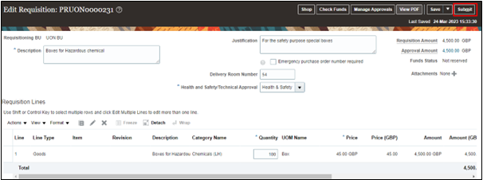

A confirmation message will be displayed when requisition has been submitted successfully.
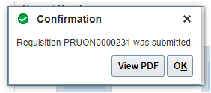

Once submitted, Purchase requisition will be approved and will fall into the buyer’s pool/process requisition area to be manually converted into a Purchase Order by the buyer.

